Full Stack Development with MERN
Project Documentation
1. Introduction
• Project Title: Customer Registry
• Team Members:
Janaki Ramaiah Himaja(member 1) - Backend Developer
Dommeti Naga Vasusri(member 2) – Frontend Developer
2. Project Overview
• Purpose:
Customer Registry is a secure web-based complaint management system developed using the MERN (MongoDB, Express.js, React.js, Node.js) stack. The system is designed to replace traditional manual complaint handling methods with a centralized digital platform where customer complaints can be managed efficiently.
The application enables authenticated users to register, log in securely, create customer complaints, update complaint information, view complaint history, and delete resolved or unnecessary complaints. By integrating JWT-based authentication with MongoDB Atlas, the application ensures secure access and reliable cloud-based data storage.
The primary goal of the project is to improve complaint management by providing an organized, secure, and user-friendly system that enhances efficiency and minimizes manual effort.
Features:
The Customer Registry application includes the following features:
User Authentication
- User Registration
- Secure Login
- JWT Authentication
- Logout
Complaint Management
- Register Complaint
- View Complaints
- Edit Complaint
- Delete Complaint
Dashboard
- Display complaint records
- Quick navigation
- Complaint management
Database Management
- MongoDB Atlas integration
- Secure storage
- CRUD operations
Security
- Password hashing
- JWT Token verification
- Protected API routes
- Input validation

3. Architecture
• Frontend:
Frontend Architecture (React.js)
The frontend of the Customer Registry application is developed using React.js, a component-based JavaScript library that enables the creation of dynamic and responsive user interfaces. React's reusable component architecture improves maintainability and simplifies future enhancements.
The application follows a Single Page Application (SPA) architecture, where navigation between pages is handled using React Router without reloading the browser. The user interface consists of independent components such as Login, Register, Dashboard, Add Complaint, My Complaints, and Profile, each responsible for a specific functionality.
Frontend Components
- Login Component: Authenticates users using JWT-based login.
- Register Component: Allows new users to create an account.
- Dashboard Component: Serves as the central page after successful login.
- Add Complaint Component: Provides a form for submitting customer complaints.
- My Complaints Component: Displays complaints submitted by the logged-in user with options to update or delete them.
- Profile Component: Displays user-related information.
Frontend Workflow
- User interacts with the React interface.
- React validates form inputs.
- API requests are sent to the backend using Axios.
- JWT tokens are stored in local storage after successful authentication.
- Protected routes use the stored token to access secured backend endpoints.
- The received data is dynamically rendered without refreshing the page.
Frontend Technologies
- React.js
- React Router DOM
- Axios
- HTML5
- CSS3
- JavaScript (ES6+)

• Backend:
Backend Architecture (Node.js & Express.js)
The backend is built using Node.js with the Express.js framework, providing RESTful APIs that handle authentication, complaint management, and communication with the MongoDB database.
The application follows a modular architecture by separating routes, controllers, models, middleware, and database configuration. This improves scalability, readability, and code maintenance.
Backend Modules
Authentication Module
- User Registration
- User Login
- Password Encryption using bcrypt
- JWT Token Generation
Complaint Module
- Add Complaint
- View User Complaints
- Update Complaint
- Delete Complaint
Middleware
- JWT Authentication Middleware
- Token Verification
- Authorization for protected routes
Backend Request Flow
- Client sends an HTTP request.
- Express Router directs the request to the appropriate route.
- Authentication middleware verifies the JWT token.
- Controller processes the business logic.
- Mongoose communicates with MongoDB.
- The server returns a JSON response to the frontend.
Backend Technologies
- Node.js
- Express.js
- JWT (JSON Web Token)
- bcrypt.js
- Mongoose ODM
- dotenv

Database:
The Customer Registry application uses MongoDB Atlas, a cloud-based NoSQL database, to store user accounts and complaint records. Mongoose is used as the Object Data Modeling (ODM) library to define schemas and interact with the database.
4. Setup Instructions
• Prerequisites:
Before running the project, install the following software:
- Node.js (v18 or later)
- npm
- MongoDB Atlas Account
- Git
- Visual Studio Code
- Postman
- Modern Web Browser (Chrome/Edge)
Installation: Step-by-step guide to clone, install dependencies, and set up the environment variables.
Step 1: Clone the Repository - git clone https://github.com/yourusername/customer-registry.git
Step 2: Navigate to the Project Folder - cd Customer-Registry
Step 3: Install Frontend Dependencies - cd Client
npm install
Step 4: Install Backend Dependencies - cd ../Server/server
npm install
5. Folder Structure
• Client:

Folder/File | Description
public/ | Stores static files such as the HTML template and public assets.
src/ | Contains the main source code of the React application.
assets/ | Stores images, icons, logos, and other static resources.
components/ | Contains reusable UI components used across multiple pages.
pages/ | Includes application pages such as Login, Register, Dashboard, Add Complaint, My Complaints, and Profile.
services/ | Contains Axios configuration and API service methods for backend communication.
App.jsx | Defines application routing using React Router.
main.jsx | Entry point of the React application that renders the root component.
index.css | Contains global styles for the application.
package.json | Lists project dependencies and scripts.
vite.config.js | Configuration file for the Vite development server.

• Server:

Folder/File | Description
config/ | Contains the MongoDB database connection configuration.
controllers/ | Implements business logic for authentication and complaint management.
middleware/ | Contains JWT authentication middleware to protect secured API routes.
models/ | Defines Mongoose schemas for User and Complaint collections.
routes/ | Maps HTTP requests to the appropriate controller functions.
.env | Stores environment variables such as MongoDB URI, JWT secret, and server port.
server.js | Main entry point that initializes the Express server, middleware, routes, and database connection.
package.json | Contains backend dependencies, scripts, and project metadata.
package-lock.json | Maintains the exact versions of installed packages.

6. Running the Application
Step 1: Clone the Repository
git clone https://github.com/jhimaja/Customer-Registry.git
cd Customer-Registry
Step 2: Install Dependencies
Frontend
Navigate to the client directory and install the required packages.
cd client
npm install
Backend
Open a new terminal, navigate to the server directory, and install the required packages.
cd server
npm install
Step 3: Start the Backend Server
Navigate to the server directory and run:
npm start
The backend server will start on:
http://localhost:5000
Step 4: Start the Frontend Server
Open another terminal, navigate to the client directory, and run:
npm start
The frontend application will be available at:
http://localhost:5173

7. API Documentation
The Customer Registry backend provides RESTful APIs for user authentication and complaint management. All APIs exchange data in JSON format. Complaint-related endpoints are protected using JWT (JSON Web Token) authentication, requiring a valid token in the Authorization header.
API Endpoints
Method | Endpoint | Description | Authentication
POST | /api/auth/register | Registers a new user by accepting name, email, and password. | No
POST | /api/auth/login | Authenticates a user and returns a JWT token. | No
POST | /api/complaints | Creates a new complaint for the authenticated user. | Yes
GET | /api/complaints | Retrieves all complaints submitted by the logged-in user. | Yes
PUT | /api/complaints/:id | Updates an existing complaint using its unique ID. | Yes
DELETE | /api/complaints/:id | Deletes a complaint based on its unique ID. | Yes
Request and Response Format
- Request Format: JSON
- Response Format: JSON
- Authentication: JWT (Bearer Token)
- Base URL: http://localhost:5000/api
8. Authentication
The Customer Registry application uses JSON Web Token (JWT)-based authentication to provide secure access to the system. During user registration, passwords are encrypted using bcrypt before being stored in the MongoDB database. When a user logs in with valid credentials, the server generates a JWT token, which is returned to the client.
The frontend stores the JWT token and includes it in the Authorization header (Bearer <token>) for all protected API requests. On the backend, an authentication middleware verifies the token before allowing access to secured endpoints such as adding, viewing, updating, or deleting complaints. If the token is invalid, expired, or missing, the server returns an Unauthorized (401) response.
Authentication Features
- User registration with encrypted passwords using bcrypt.
- Secure user login with JWT token generation.
- Token-based authentication for protected API endpoints.
- Authorization middleware verifies user identity before processing requests.
- Only authenticated users can perform CRUD operations on their own complaints.
- No server-side sessions are used; the application follows a stateless authentication mechanism using JWT.
9. User Interface
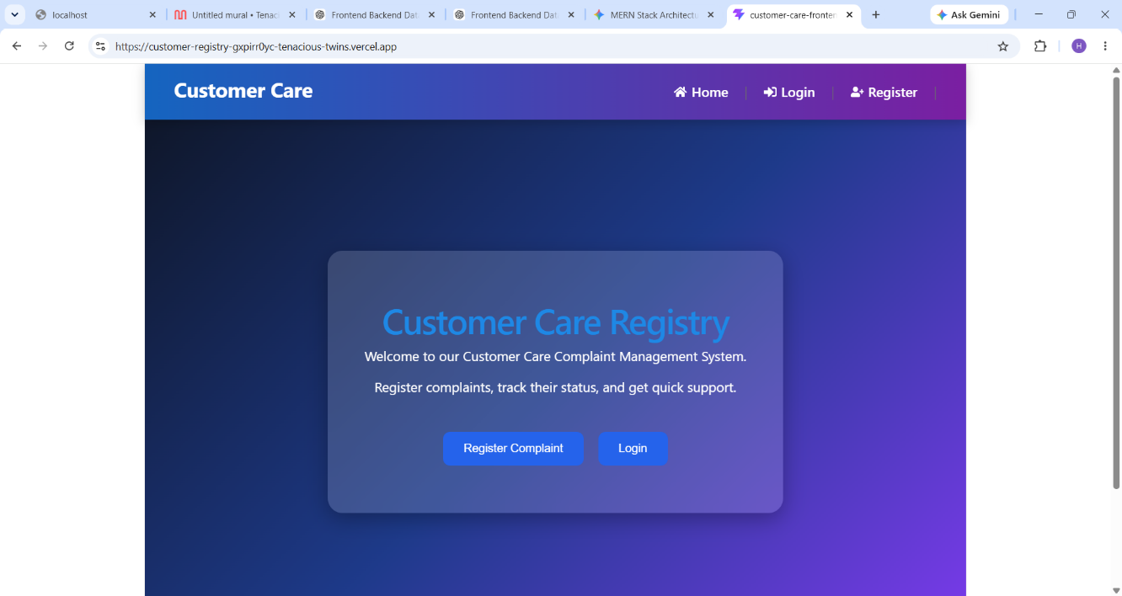
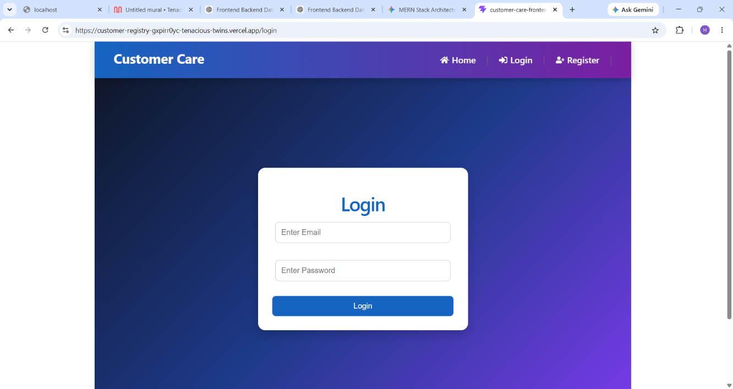
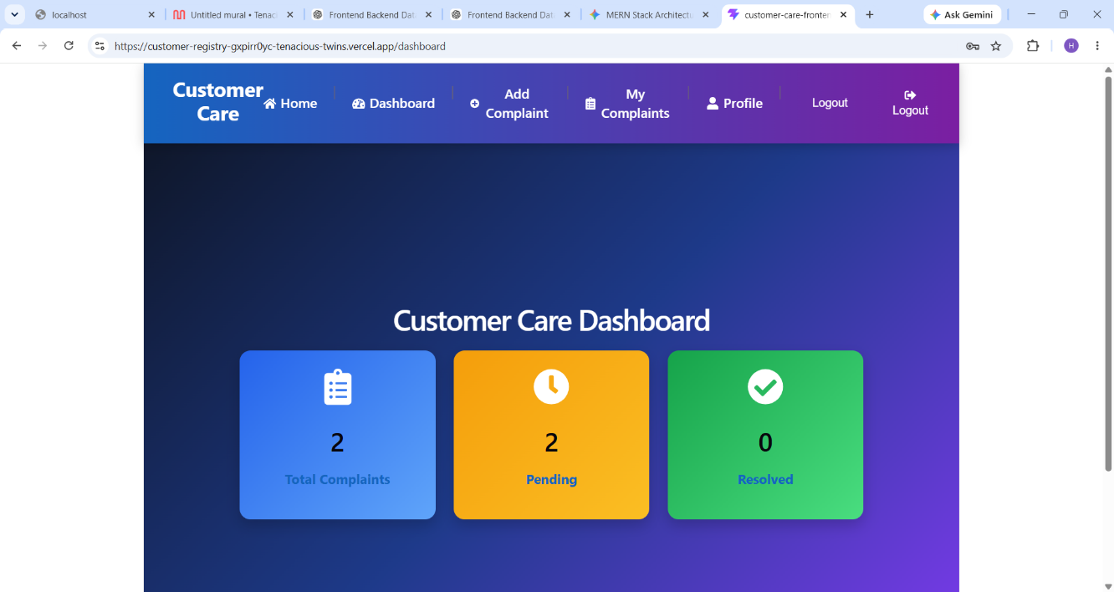
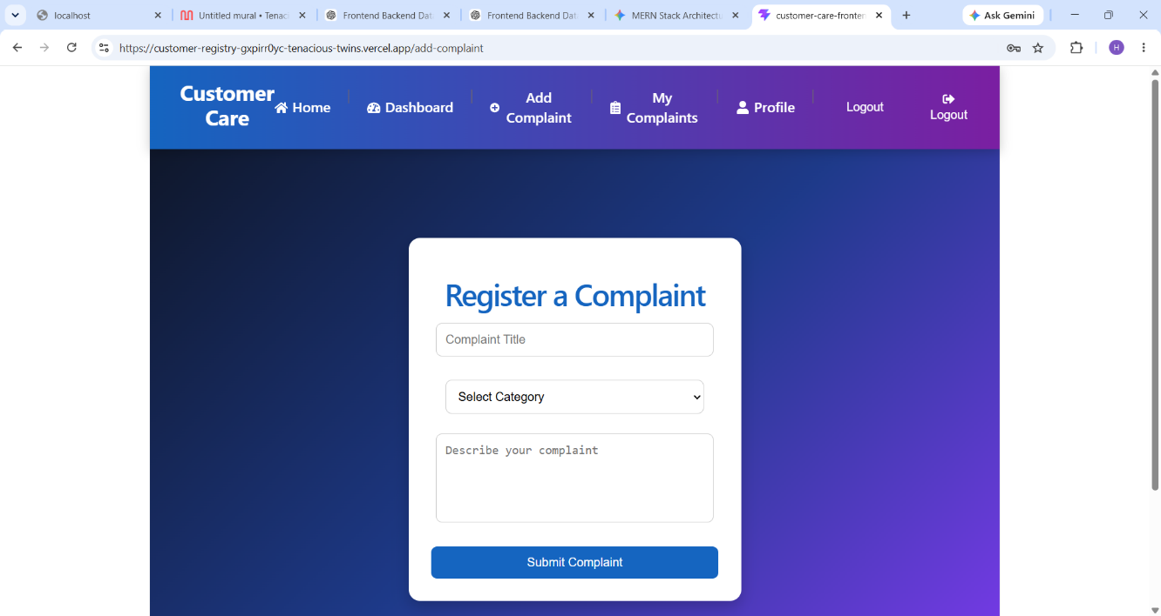
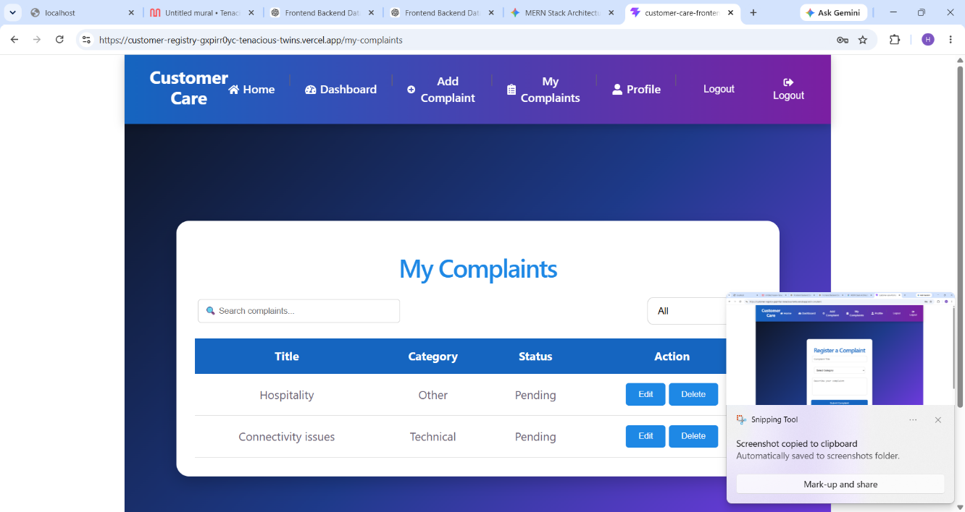
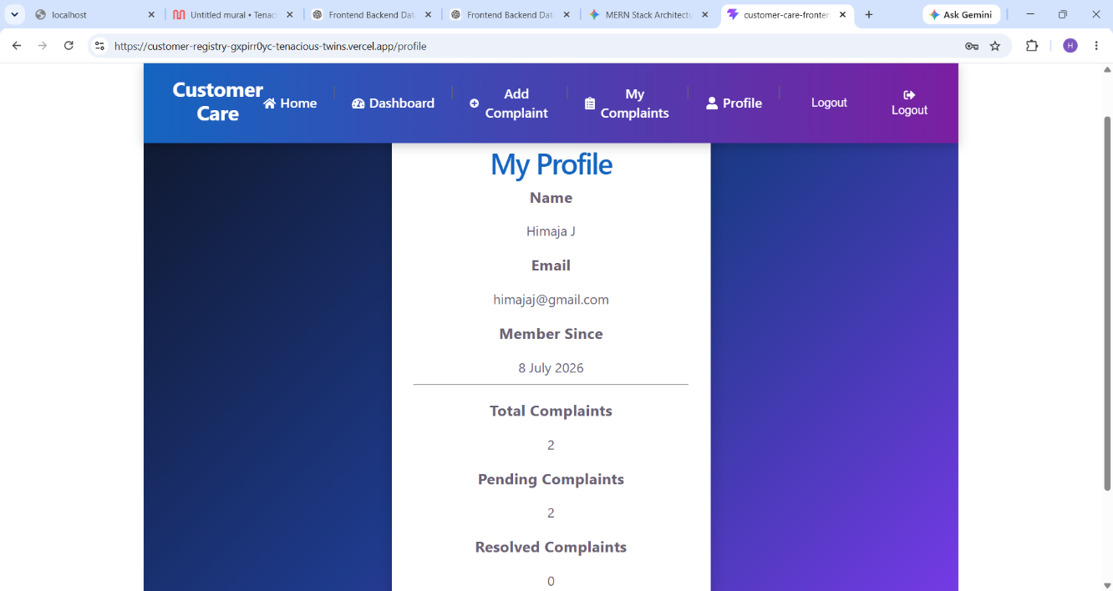
10. Testing
The Customer Registry application was tested to ensure that all major functionalities worked correctly and that data was securely handled between the frontend and backend.
Testing Strategy
- Unit Testing: Individual backend functions, such as user authentication and complaint operations, were tested during development.
- Integration Testing: Verified communication between the React frontend, Express.js backend, and MongoDB database.
- Functional Testing: Tested core features including user registration, login, adding complaints, viewing complaints, updating complaints, and deleting complaints.
- Authentication Testing: Ensured that protected API endpoints were accessible only to authenticated users using JWT tokens.
- Validation Testing: Checked form validations and handled invalid inputs, missing fields, and unauthorized access appropriately.
Testing Tools Used
- Postman: Used to test REST API endpoints and verify request and response data.
- MongoDB Compass: Used to inspect and verify data stored in the MongoDB database.
- Web Browser (Google Chrome): Used to test the user interface, navigation, and overall application functionality.
- Visual Studio Code: Used for debugging and monitoring application logs during development.
The testing process confirmed that the application correctly performs user authentication, securely manages customer complaints, and provides reliable CRUD functionality with proper error handling.
11. Screenshots or Demo
https://drive.google.com/file/d/1Ait7nk9BFdmOtz5fDEr4eGmXEGq2S78S/view?usp=sharing
12. Known Issues
At the time of submission, the Customer Registry application is fully functional for user authentication and complaint management. However, the following limitations and potential improvements have been identified:
- The application currently supports basic JWT-based authentication without features such as password reset or email verification.
- Input validation is limited to essential checks and can be enhanced with more comprehensive client-side and server-side validation.
- The application is designed for single-user complaint management and does not include role-based access control (e.g., Admin and Customer roles).
- Error messages are basic and can be improved to provide more user-friendly feedback.
- The application has been tested primarily in a local development environment and may require additional configuration for production deployment.
- Additional features such as complaint search, filtering, sorting, and pagination are not currently implemented but can be added in future versions.
These issues do not affect the core functionality of the application, and the system successfully performs user authentication and complete CRUD operations for customer complaints.
13. Future Enhancements
The Customer Registry application can be further enhanced by adding new features and improving its functionality, security, and user experience. Some potential future enhancements include:
- Implement role-based access control (RBAC) to support separate Admin and Customer dashboards.
- Add email verification and forgot/reset password functionality for improved account security.
- Introduce complaint search, filtering, sorting, and pagination to manage large numbers of complaints efficiently.
- Enable file attachments so users can upload supporting documents or images with their complaints.
- Implement complaint status tracking (e.g., Pending, In Progress, Resolved, Closed) with real-time updates.
- Send email or in-app notifications to inform users about complaint status changes.
- Improve the user interface by making the application fully responsive for mobile and tablet devices.
- Deploy the application on cloud platforms such as Vercel (frontend), Render/Railway (backend), and MongoDB Atlas for production use.
- Add analytics and reporting dashboards to help administrators monitor complaint trends and system performance.
- Integrate automated testing and CI/CD pipelines to improve software quality and streamline deployment.
These enhancements would make the Customer Registry application more secure, scalable, user-friendly, and suitable for real-world organizational use.

